[](https://sports-future.co.uk/)

**Gymnastics/Sports and Football & Multi-skills Clubs**

All the below clubs are booked through the website: [Woodridge School Clubs Archives - Football's Future (footballs-future.com)](https://footballs-future.com/product-category/school-clubs/woodridge-school-clubs/)

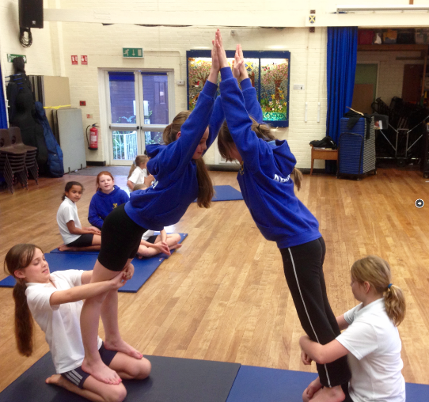

**Gym and sports club, Year 3-6**

**Wednesdays 8am - 8:50am with Mr Mapes**

Breakfast Junior Gymnastics & sports Club improving skill and technique through fun based learning. All coaches are First Aid Trained & enhanced CRB checked.

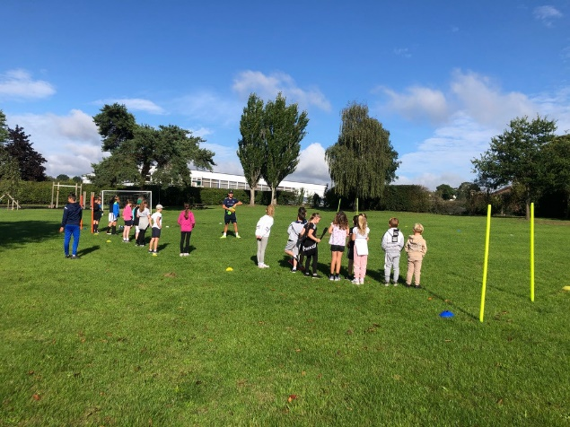

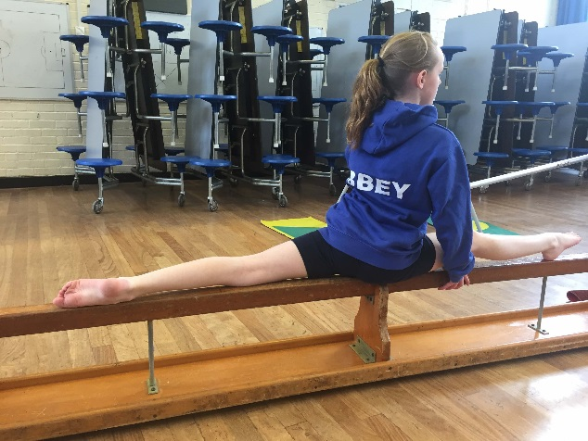

**Football & Multi sports club, Year Reception – Year 2**

**Wednesdays 15:25-16:30 with Mr Mapes**

After school Multi-Sport and football club, improving children’s skills through fun based learning & matches. Children are expected to wear suitable clothing.

**Football & Multi sports club, Year Reception – Year 2**

**Thursdays 15:25-16:30 with Mr Mapes**

After school Multi-Sport and football club, improving children’s skills through fun based learning & matches. Children are expected to wear suitable clothing.