
Gymnastics/Sports and Football & Multi-skills Clubs

All the below clubs are booked through the website: Woodridge School Clubs Archives - Football's Future (footballs-future.com)

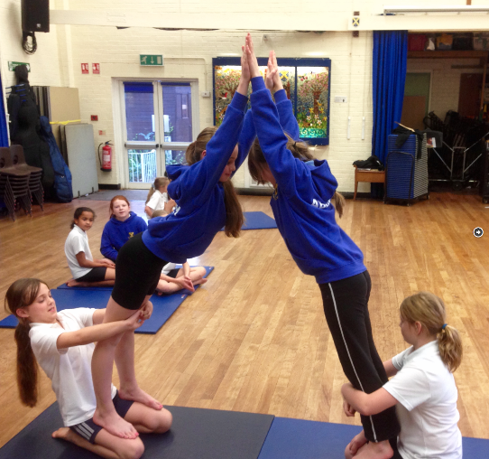

Gym and sports club, Year 3-6
Wednesdays 8am - 8:50am with Mr Mapes

Breakfast Junior Gymnastics & sports Club improving skill and technique through fun based learning. All coaches are First Aid Trained & enhanced CRB checked.

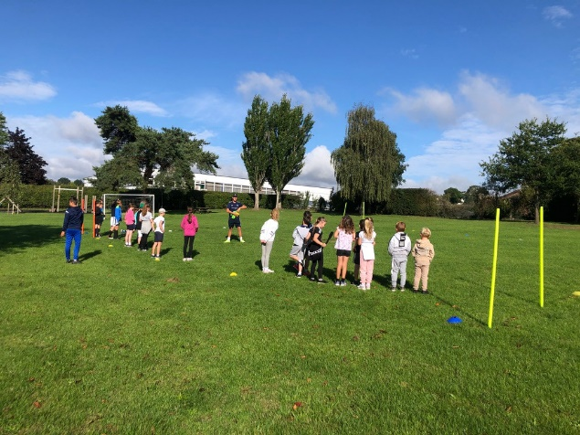

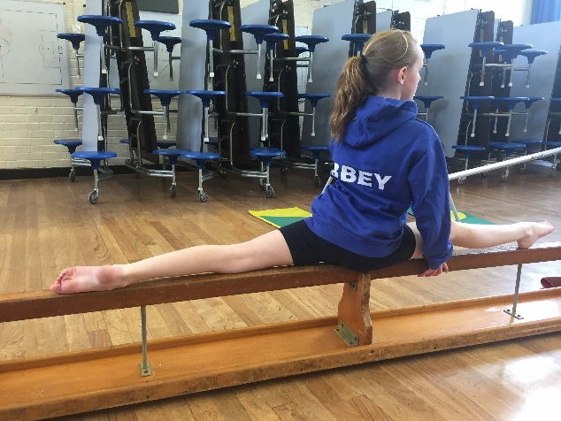

Football & Multi sports club, Year Reception – Year 2
Wednesdays 15:25-16:30 with Mr Mapes

After school Multi-Sport and football club, improving children’s skills through fun based learning & matches. Children are expected to wear suitable clothing.

Football & Multi sports club, Year Reception – Year 2
Thursdays 15:25-16:30 with Mr Mapes

After school Multi-Sport and football club, improving children’s skills through fun based learning & matches. Children are expected to wear suitable clothing.

