
Gymnastics/Sports and Football & Multi-skills Clubs

All the below clubs are booked through the website: Woodridge School Clubs Archives - Football's Future (footballs-future.com)

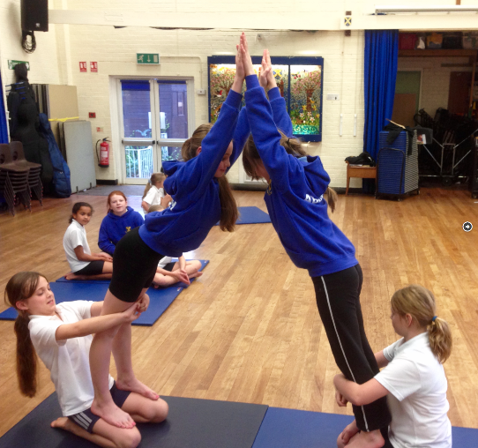

Gym and sports club,
Year 3-6, Wednesdays 8am - 8:50am

Breakfast Junior Gymnastics & sports Club improving skill and technique through fun based learning. All coaches are First Aid Trained & enhanced CRB checked.

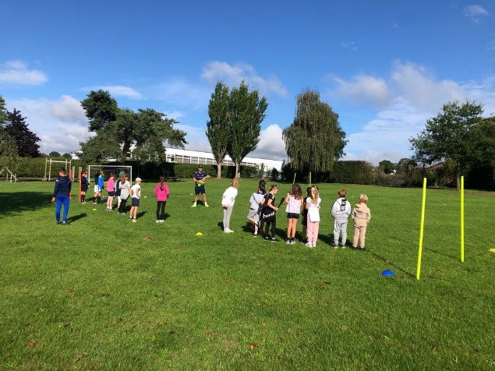

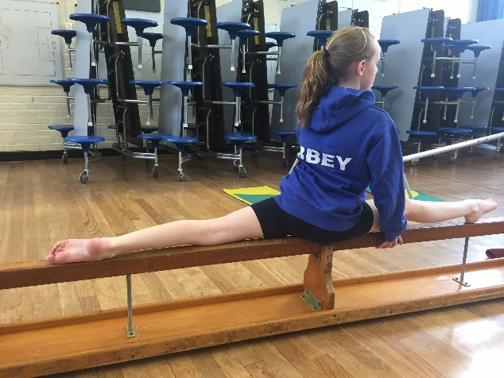

Football & Multi sports club,
Rec – Year 2, Wednesdays 15:25-16:30

After school Multi-Sport and football club, improving children’s skills through fun based learning & matches. Children are expected to wear suitable clothing.

Football & Multi sports club,
Rec - Year 2, Thursdays 15:25-16:30

After school Multi-Sport and football club, improving children’s skills through fun based learning & matches. Children are expected to wear suitable clothing.

